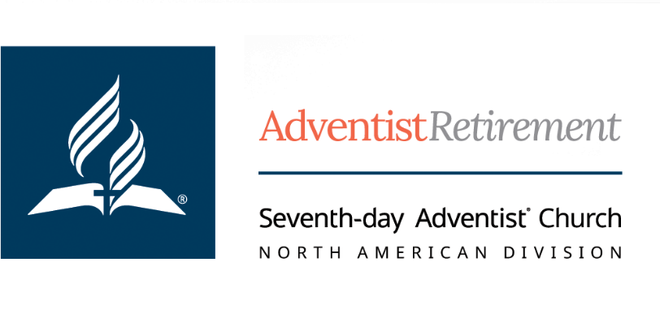

Housing Allowance Information - Do Not Discard!

January 2024

To: Retired Ministers
From: Andrew Choi, Chief Financial Officer

At the beginning of February, you should receive from us your Form 1099-R for your benefits. At the end of last year, we voted to designate up to 100 percent of your monthly retirement benefits as eligible for housing allowance exclusion, subject to these limits:

You must have actually spent the money on qualifying expenses, and regardless of how much you spent, you can’t reduce your income more than the fair rental value of your home plus utilities. (For more on this, see the first question, next page.)

On a retired minister’s 1099-R, we mark box 2b as ‘Taxable amount not determined.’ We also leave box 2a, “Taxable Distribution” blank. This is deliberate and follows IRS instructions. It is up to the retired minister to document what portion of the pension has been used for qualifying housing allowance if questioned by the IRS. Unlike your employment housing allowance, please do NOT send us a report of your housing expenses.

If your actual qualifying expenses for providing a home during this year are less than the amount in box 1 of your 1099-R, tax rules require you to report the difference as a taxable distribution. Failure to report unused parsonage allowance would be a violation of the Internal Revenue Code that could result in substantial penalties. On form 1040 the line labeled Pensions and annuities*, enter the total minister’s pension amount. Enter the taxable benefit, if any, in the corresponding box after subtracting qualifying housing expenses from the total minister’s pension.

Here are various categories of expenses generally believed to qualify for parsonage allowance exclusion, subject to the Fair Rental Value and Actual Expenditures limits.

- Mortgage Payments or Rent
- Real estate Commission, Escrow Fees
- Real & Personal Property Taxes
- Homeowner’s & Contents Insurance
- Down Payment on Primary Residence
- Homeowner’s Association or Condo Fees
- Home Maintenance, Furnishings, Decorating, Lawn Maintenance
- Utilities (gas, power, water, base phone, trash, basic cable)

Accompanying this letter are some Frequently Asked Questions. This letter provides general information we believe to be accurate but is not intended to be used as specific tax advice for your situation. You may wish to consult a tax expert.

*Please note that references to the IRS Form 1040 are for illustrative purposes only. The Internal Revenue Service updates their forms periodically and may relabel sections and boxes on the Form 1040. You can view the most current Form 1040 on the IRS website irs.gov. Please consult with your tax preparer to ensure accurate reporting.

9705 Patuxent Woods Drive • Columbia, MD 21046 • (443) 391-7300
Email: NADRetirement@nadadventist.org • adventistretirement.org

Frequently Asked Questions About Parsonage Allowance Exclusion

I have paid my mortgage off and thus have no monthly payments on my home. Can I use the “Fair Rental Value” as an expense to increase my parsonage expenses?

No. The IRS only allows you to use actual expenditures for exclusion from taxable income. Fair Rental Value is a LIMIT only.

I got more than one 1099 form from you. Which is eligible for Parsonage Allowance Exclusion?

1099-R has a “7" in the Distribution Code box. This is for your Monthly benefits plus the one-time lump sum Retirement Allowance if this was your retirement year and you were eligible for the RA. “x” in box
2b. Eligible for exclusion

1099-R has a “G” in the Distribution Code box. We rolled a Retirement Allowance into an Individual Retirement Account at your request. Not taxable at this time. Not eligible for exclusion.

For part of this year I worked for a local conference. Is it possible to coordinate my exclusion for the year between the retirement plan and the conference?

Yes. When you report to the conference your housing expenses to be excluded from your W-2 income, you may wish to report only those expenses that exceed your benefits from this office. You should not reduce both your W-2 income from the conference and your taxable income from this office by using the same expenses.

How can I maximize my parsonage allowance?

Spend money on your home! According to information provided to us, you cannot:

- Use an estimated “fair rental value” in lieu of actual expenses

- Draw down a home equity line of credit merely for the purpose of paying back as a parsonage expense. Generally, a home equity line of credit should be used for actual housing expenses to qualify for the exclusion. See a tax advisor on this item.

Is unused parsonage allowance taxable?

Yes, for income tax. However, it is not taxable for SECA (self-employment) purposes. For a retired minister, that portion of a pension paid from a denominational retirement plan is excluded under Code Section 107.

I’m hired by the conference on a part-time stipend basis. Do I have to pay SECA?

Yes. A stipend is merely another word for wages. There is no relief for post-retirement employment.

Continued on the next page

Frequently Asked Questions continued…

If my housing expenses exceed my denominational pension income, can I use extra parsonage expenses to reduce my tax from other income, such as interest income?

No. You can generally only use the exclusion to reduce income from ministry.

If I pass away, is my spouse’s survivor benefit eligible for Parsonage Allowance Exclusion?

No. The IRS considers survivor benefits as belonging to the spouse who was not eligible for parsonage allowance exclusion regardless of how that benefit was earned. Why? We don’t get it either, but IRS is quite clear on this.

Can my withdrawal from a tax deferred investment such as an IRA, a Tax Deferred Annuity, or an Adventist Retirement Account be eligible for Parsonage Allowance Exclusion?

Our legal counsel has advised us that only withdrawals from a church plan can be marked as required for parsonage allowance exclusion eligibility, that is, box 2a blank and 2b checked. Empower Retirement is our record-keeper for the church’s defined contribution retirement plan, and is authorized by us, the plan sponsor to mark the 1099-R’s in this way but only for withdrawals from the Adventist Plan. Thus, withdrawals from any annuity, IRA or other tax-deferred instrument will likely not be eligible for parsonage allowance exclusion. Even VALIC or Empower Retirement products are not eligible for the exclusion unless they are part of the Adventist Retirement Plan.

Note: This issue is complex and not all tax preparers will agree with our attorneys. We are not authorized to give tax advice. You may wish to consult your own tax preparer on the matter of Parsonage Allowance Exclusion for withdrawal from non-church plans.

